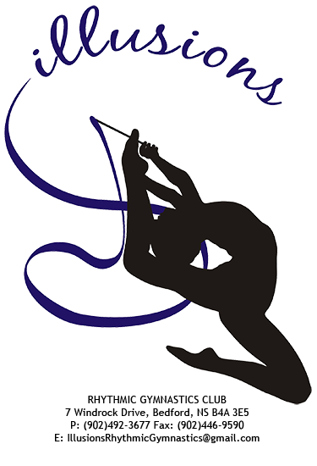

ILLLUSIONS RHYTHMIC GYMNASTICS CLUB
MINI COMPETITION – Sunday, November 29th

Hi Everyone,

Just a reminder that we are having a mini competition on Sunday, November 29, 2015 at BHPCC (11-4pm).

Please invite your friends and family! Competition will be commencing at 12:30pm

This is a fun, stress-free event! The girls will be judged but will not be receiving marks or awards. The girls (listed below) will be competing one individual routine (Freehand: Levels 1-5A OR Ribbon: Level 5B). Those athletes that are new to our competitive stream will have the option to perform their individual routine alone or with a buddy or 2 – this competition is meant to be a very positive, fun experience for everyone.

Athletes:
Competitive A: all athletes (14 athletes)
Competitive B: all athletes (13 athletes)
Competitive C: Riley, Brigid, Nikol, Anna, Grace, Paige, Malak, Katie, Melanie

Once the girls are finished competing they can watch the rest of the competition in the stands with parents/family/friends/gymnasts. New Competitive B & C athletes - since this is your first competition, Kaylee & Jill will have a list of things to watch for once you're in the stands with your family (ex. How the athletes wait in the corner until their name is called, how they walk on the carpet etc).

Here are a few details:

1) All athletes should arrive at CPA at 11am with hair/make-up done. The girls will have about 1.5 hours to warm-up and we’ll start the competition at 12:30pm.
*Parents: If you are able to stay and help with the set-up (bleachers/tables/chairs/carpet) that would be great.

2) Attire: The girls do not need to have their competition suits for this competition. If you have a competition suit (individual or group), feel free to wear it. If you don’t have a suit, please wear your black Illusions warm-up attire (solid black biking shorts and tank top/shirt/bodysuit). Apparatus does not have to match your suit.

3) Toe shoes: Please make sure that you have a pair of toe shoes to wear (no holes/broken elastics). * Toe shoe orders placed with Lisa Landry should be arriving next week.

4) Lunch/Snacks: Please make sure the girls bring a healthy lunch & snacks. They will all have an opportunity to have a quick bite to eat in the hallway before/during/after they compete. Make sure you have a big, healthy breakfast! Also, please bring a filled water bottle with your name on it.

5) Admission: $5/family & $2/individual. We will also be collecting non-perishable food donations for FEED NOVA SCOTIA.

6) Competition Registration Fee: In lieu of athlete registration fees and medals/awards, Illusions will be doing a Pajama Drive (children: newborn to age 16). We have registered our PJ Drive with FEED NOVA SCOTIA and they are beyond thrilled to receive the PJs and distribute them to deserving families during the holiday season. In the past we have always done a Secret Santa gift exchange for the athletes but this year we felt a Pajama Drive would be more rewarding and memorable for everyone. Look for the decorated laundry baskets at the competition and drop your new, unwrapped PJs inside – any style, any color, any size (newborn to age 16)!

